**(Contract Balance Update | Payable):**

In Solidity, the contract balance refers to the amount of Ether (ETH) that is currently held by a smart contract. Every Ethereum smart contract has its own balance, and you can access this balance using the **address.balance** property.

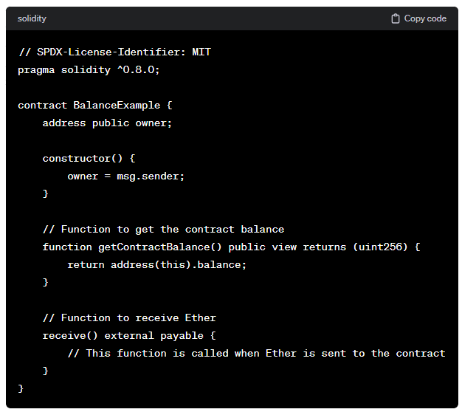

Keep in mind that if you want to send Ether out of the contract, you'll need to include a withdrawal function. Also, be cautious about handling Ether in smart contracts, as it requires proper security considerations and handling of reentrancy issues.

**Code:**

//SPDX-License-Identifier: GPL-3.0

pragma solidity ^0.8.0;

contract paynew {

    address payable user=payable(0xAb8483F64d9C6d1EcF9b849Ae677dD3315835cb2);

    function payEther() public payable

    {

    }

    function getBalance() public view returns(uint)

    {

        return address(this).balance;

    }

    function sendEtherAccount() public

    {

        user.transfer(1 ether);

    }

}

**Output:**

